Linux-02

chmod 777 filename:
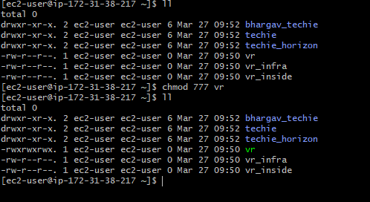
The chmod 777 command is used to give full permissions to a file or directory for all users.
rwx= owner r=4
rwx= group w=2
rwx=execute x=1
cat /etc/passwd:
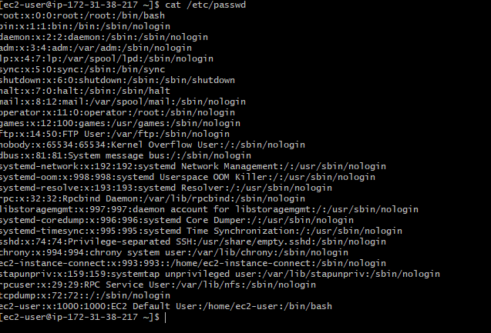
It is used to display information about all users available.
chown root:root file name:
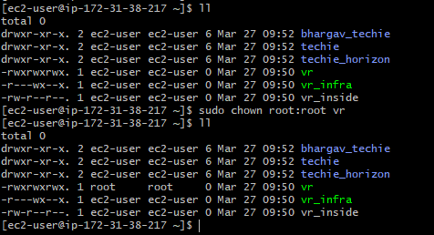
command is used to change the owner and group of a file or directory.

useradd username :
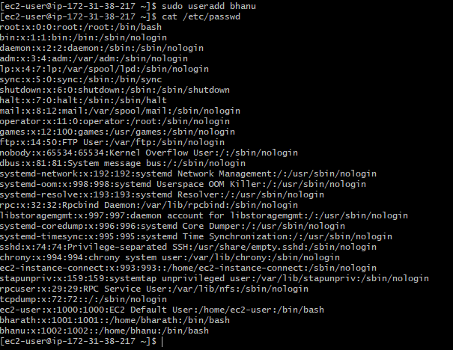
command is used to create a new user account
passwd username:
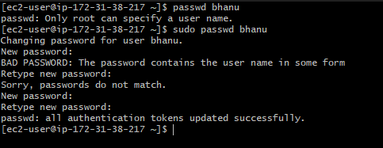
command is used to set or change the password of a user account
su username :
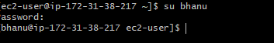
command is used to change from the current user to another user account
find / -name filename:
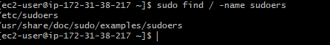
command is used to search for files and directories
echo “learning devops” > file name:
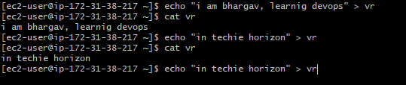
command is used to create a file and write text
echo “in techie horizon” >> filename:
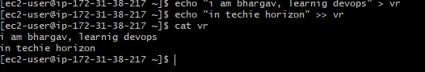
command is used to append text to an existing file
head -4 filename:
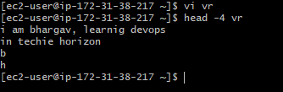
command is used to display the first lines of a file
tail -3 filename:
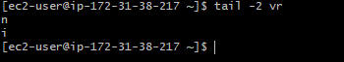
command is used to display the last lines of a file.

tail -f filename:
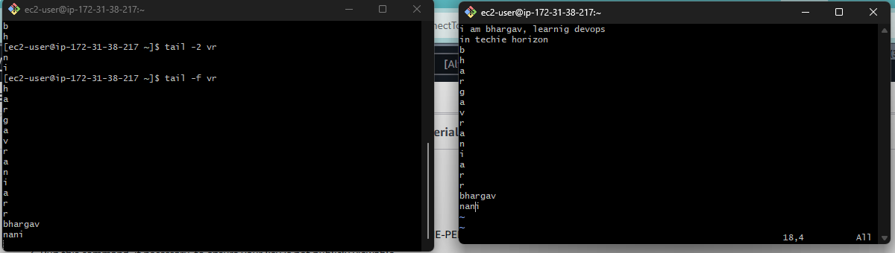
command is used to continuously monitor the live updates of a file.
grep b filename:
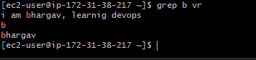
command is used to search for a word or pattern inside a file.
grep -i B filename:
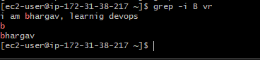
command is used to search text in a file without case sensitivity (ignores uppercase and lowercase differences).

